Urban Sketching A Workshop Day with Graham Thew

Buildings….. a brief guide to sketching them.

Artists and authors have written many detailed and interesting books manuals and articles about the myriad of ways there are to draw and sketch buildings. In the brief programme of a workshop it seems to me that the best way to approach the topic of buildings is to present a way of looking at them that will take away the fear of perspective, hard lines, minuscule detail , shapes, ornament architectural styles etc etc.
Many a good urban sketch is all about the things that happen in our townscape environment and buildings inevitably are the backdrop to that story.
Therein lies the key to sketching them. Look at them as a stage set , a backdrop that can have as much or as little detail drawn on them as you wish. Use your X-ray eyes to see through the ephemera that is street signs, aerials, street furniture, people cars, and the rest of the urban paraphernalia.
The Art of drawing buildings lies in simplifying the subject
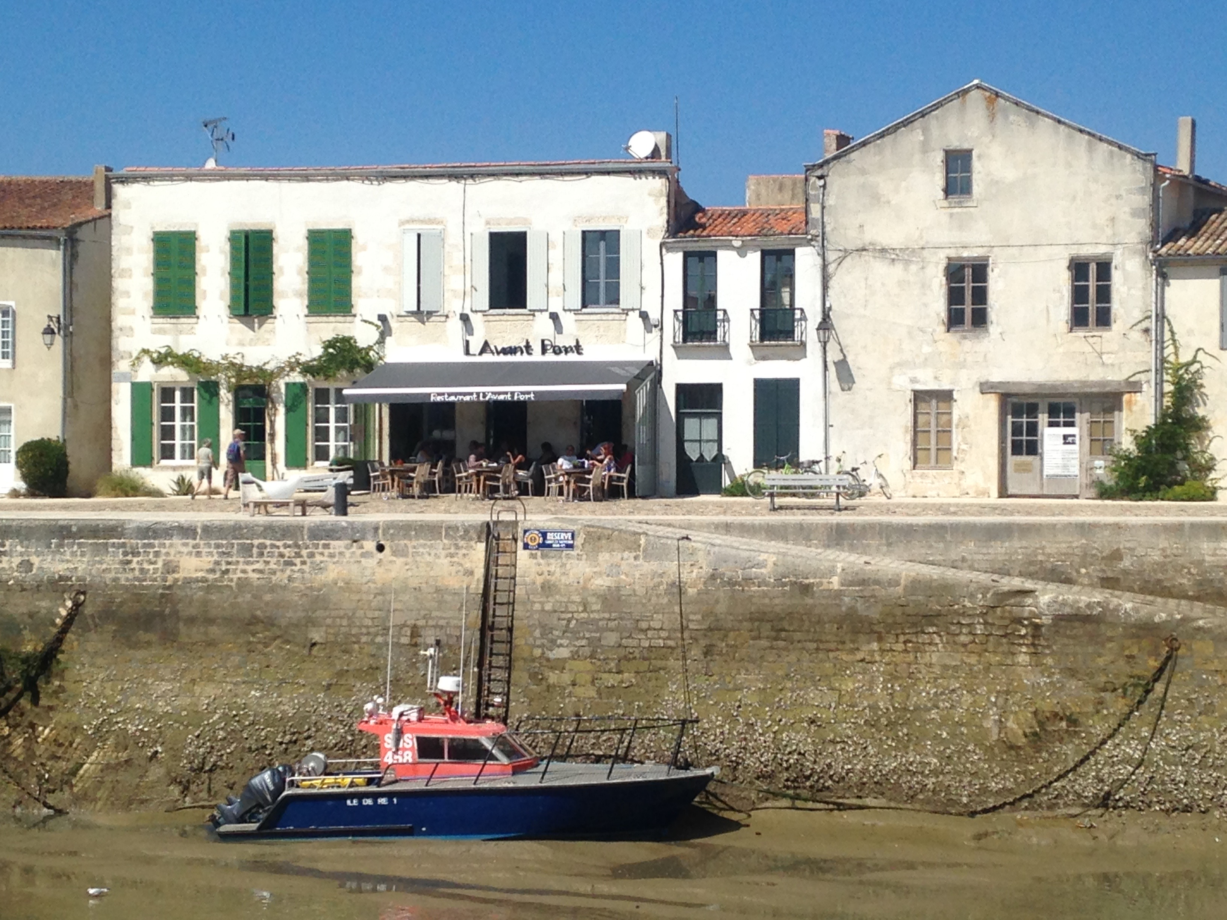
See the mass of the buildings first, look at them for what they are , giant lego-like blocks. Huge three dimensional shapes that sit on the edge of our roads and streets.
(Just before you start…. note the time)

Now set to with your sketch….
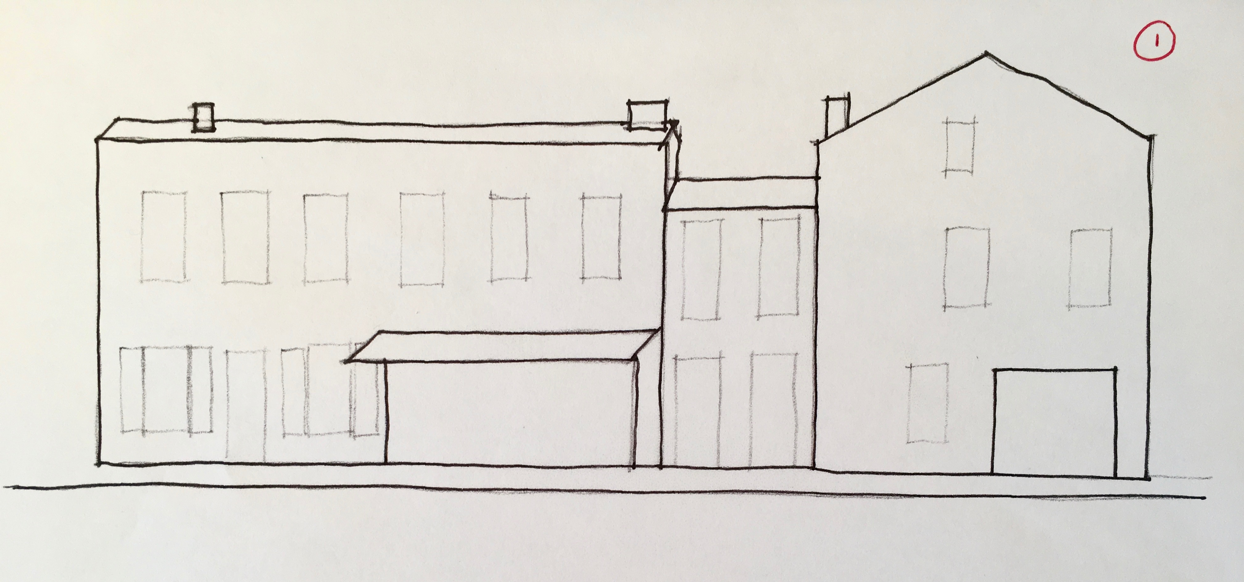
Using a fine line most probably a pencil (H.B. or 2B) Draw that block first, the simple long lines that make the front and sides (that’s if you can see the sides). Then if you can see the roof on top of the block you have created sketch that in too. don’t worry about if you are going “through” things at this time that’s why you are using a fine line, these are the guide lines for your drawing.Once you have drawn a building or a number of them,
STOP. Take a moment to review what you have set to paper. Ask yourself some questions…….. for example:
Are the vertical lines vertical?
Are the buildings the right size in proportion to one another?
Do you like the composition of your sketch so far?
Have I bitten off more than I can chew at this time?
If you don’t like what you’ve done …start again, or move on to another place to sketch….. Remember you are doing this to enjoy yourself. But also remember……. in drawing the phrase “practice makes perfect”could never have been more appropriate! The good thing about your sketch being in your book is that you cannot throw it away (which might have been your first inclination). Put a date on the drawing and write a couple of notes about why you moved on without finishing it. I promise you here and now, if you draw the same view again straight away or in the future, the sketch will improve, and that’s because you will have learnt something from the process. (And I didn’t say learnt from your mistakes!)
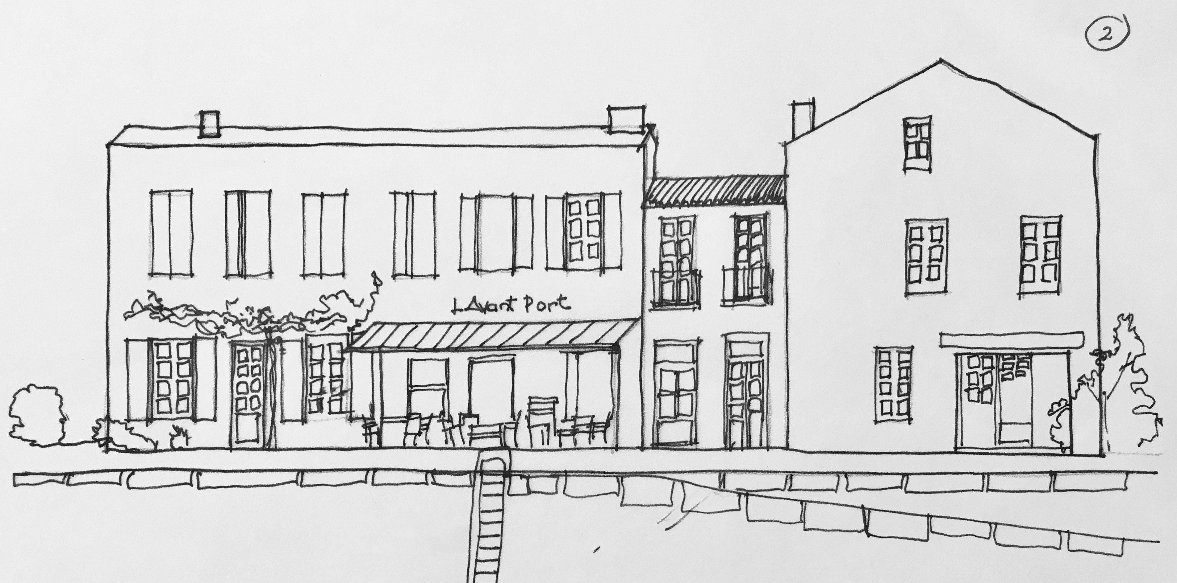
Okay, let’s assume that it’s worth pressing on. Look again, what are the next most important elements of the view in front of you? Is it the windows? the shopfronts? the tree blocking some of your view? Whatever they are sketch those in too, but with the constant awareness that each line you apply needs to relate to what you have already drawn in the right way.
In this way build up the framework of your picture.
When you are happy that the framework is complete, STOP. Take a moment to review what you have set to paper. Ask yourself some questions……for example:
Am I happy with what I have done so far?
Is there anything essential to the sketch that I have missed?
Have I fudged an area which will be important to the finished sketch?
Once you have taken that moment, stand up, have a bit of a walk around, if you are with others have a look at what they are doing, breathe.
Now return to your position, have a look at your sketch and review it again. I find just a moment away can often highlight if there’s something not quite right and provide the opportunity to tweak it before moving on to the detail stages.
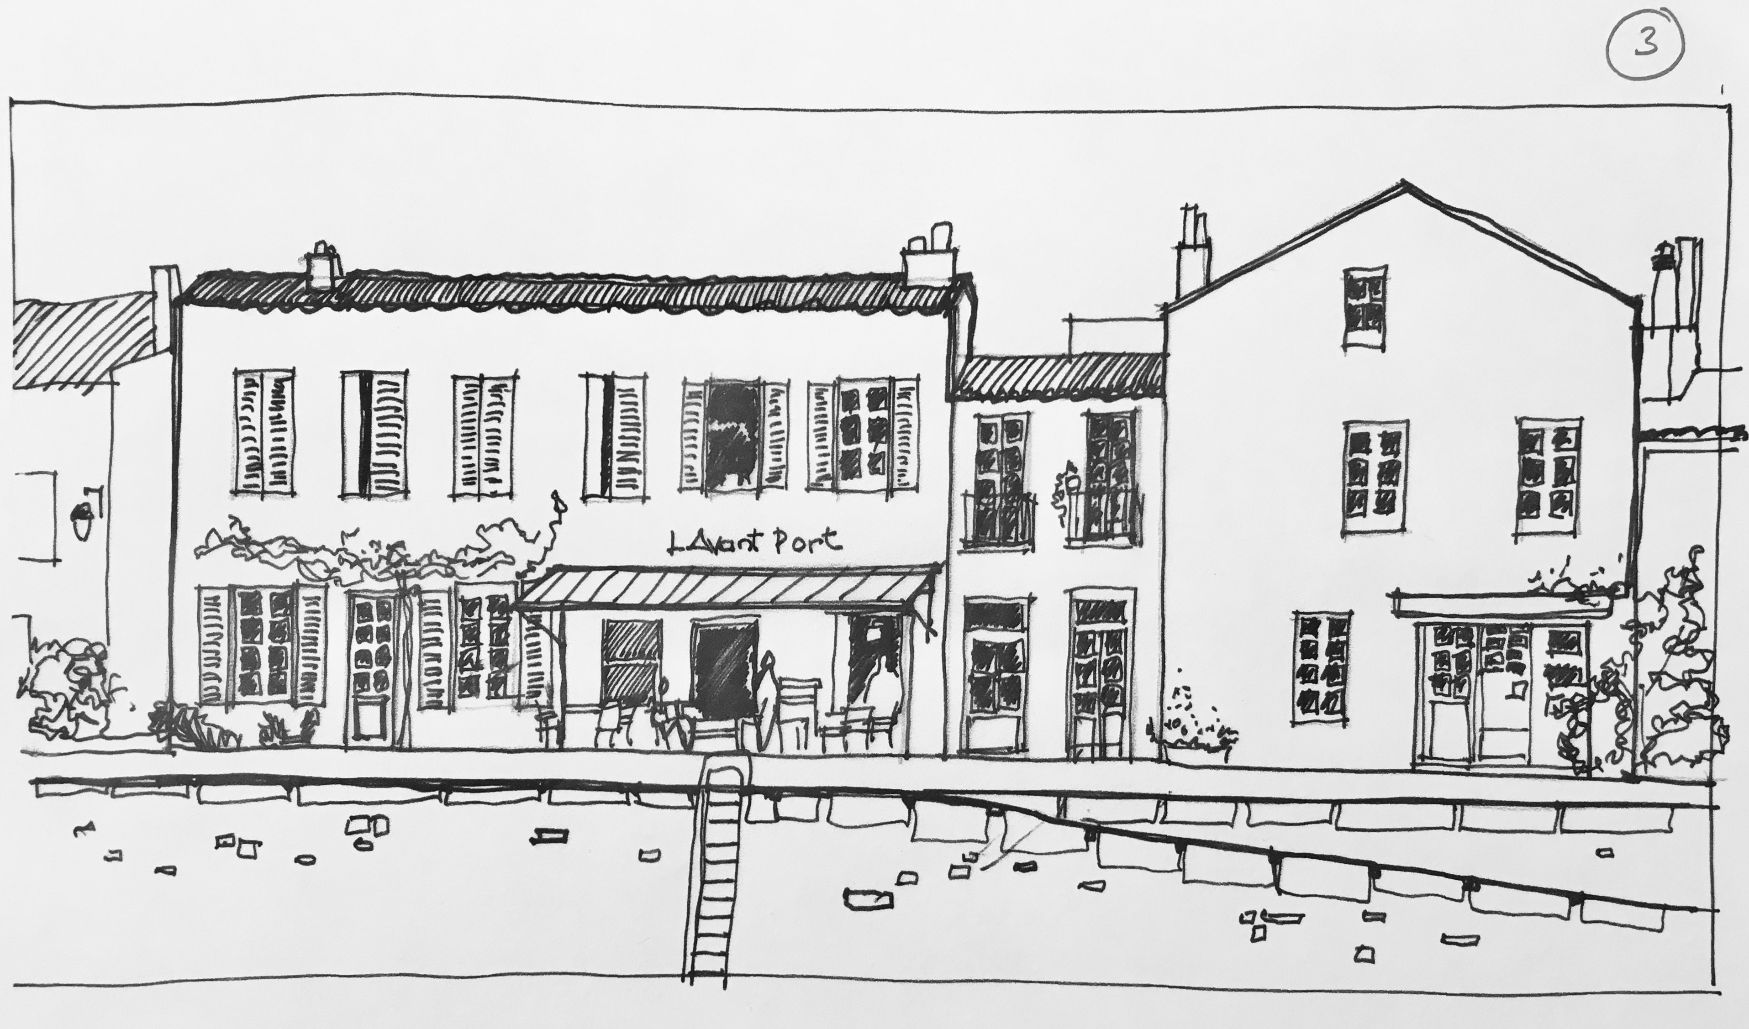
Start to harden up some lines, if you think the sketch would look good as a pen and ink work, break out the pens, if you feel colour is the important element , break out the watercolours

Your sketch has now taken a life of it’s own and will pull you along as you add detail, colour, and things that you simply didn’t see when you first sat down.
Add as much or as little detail to your scene as you want to, it’s your sketch, it’s your time, it’s your hobby.
When you are comfortable that you have done as much as you want to at this time,
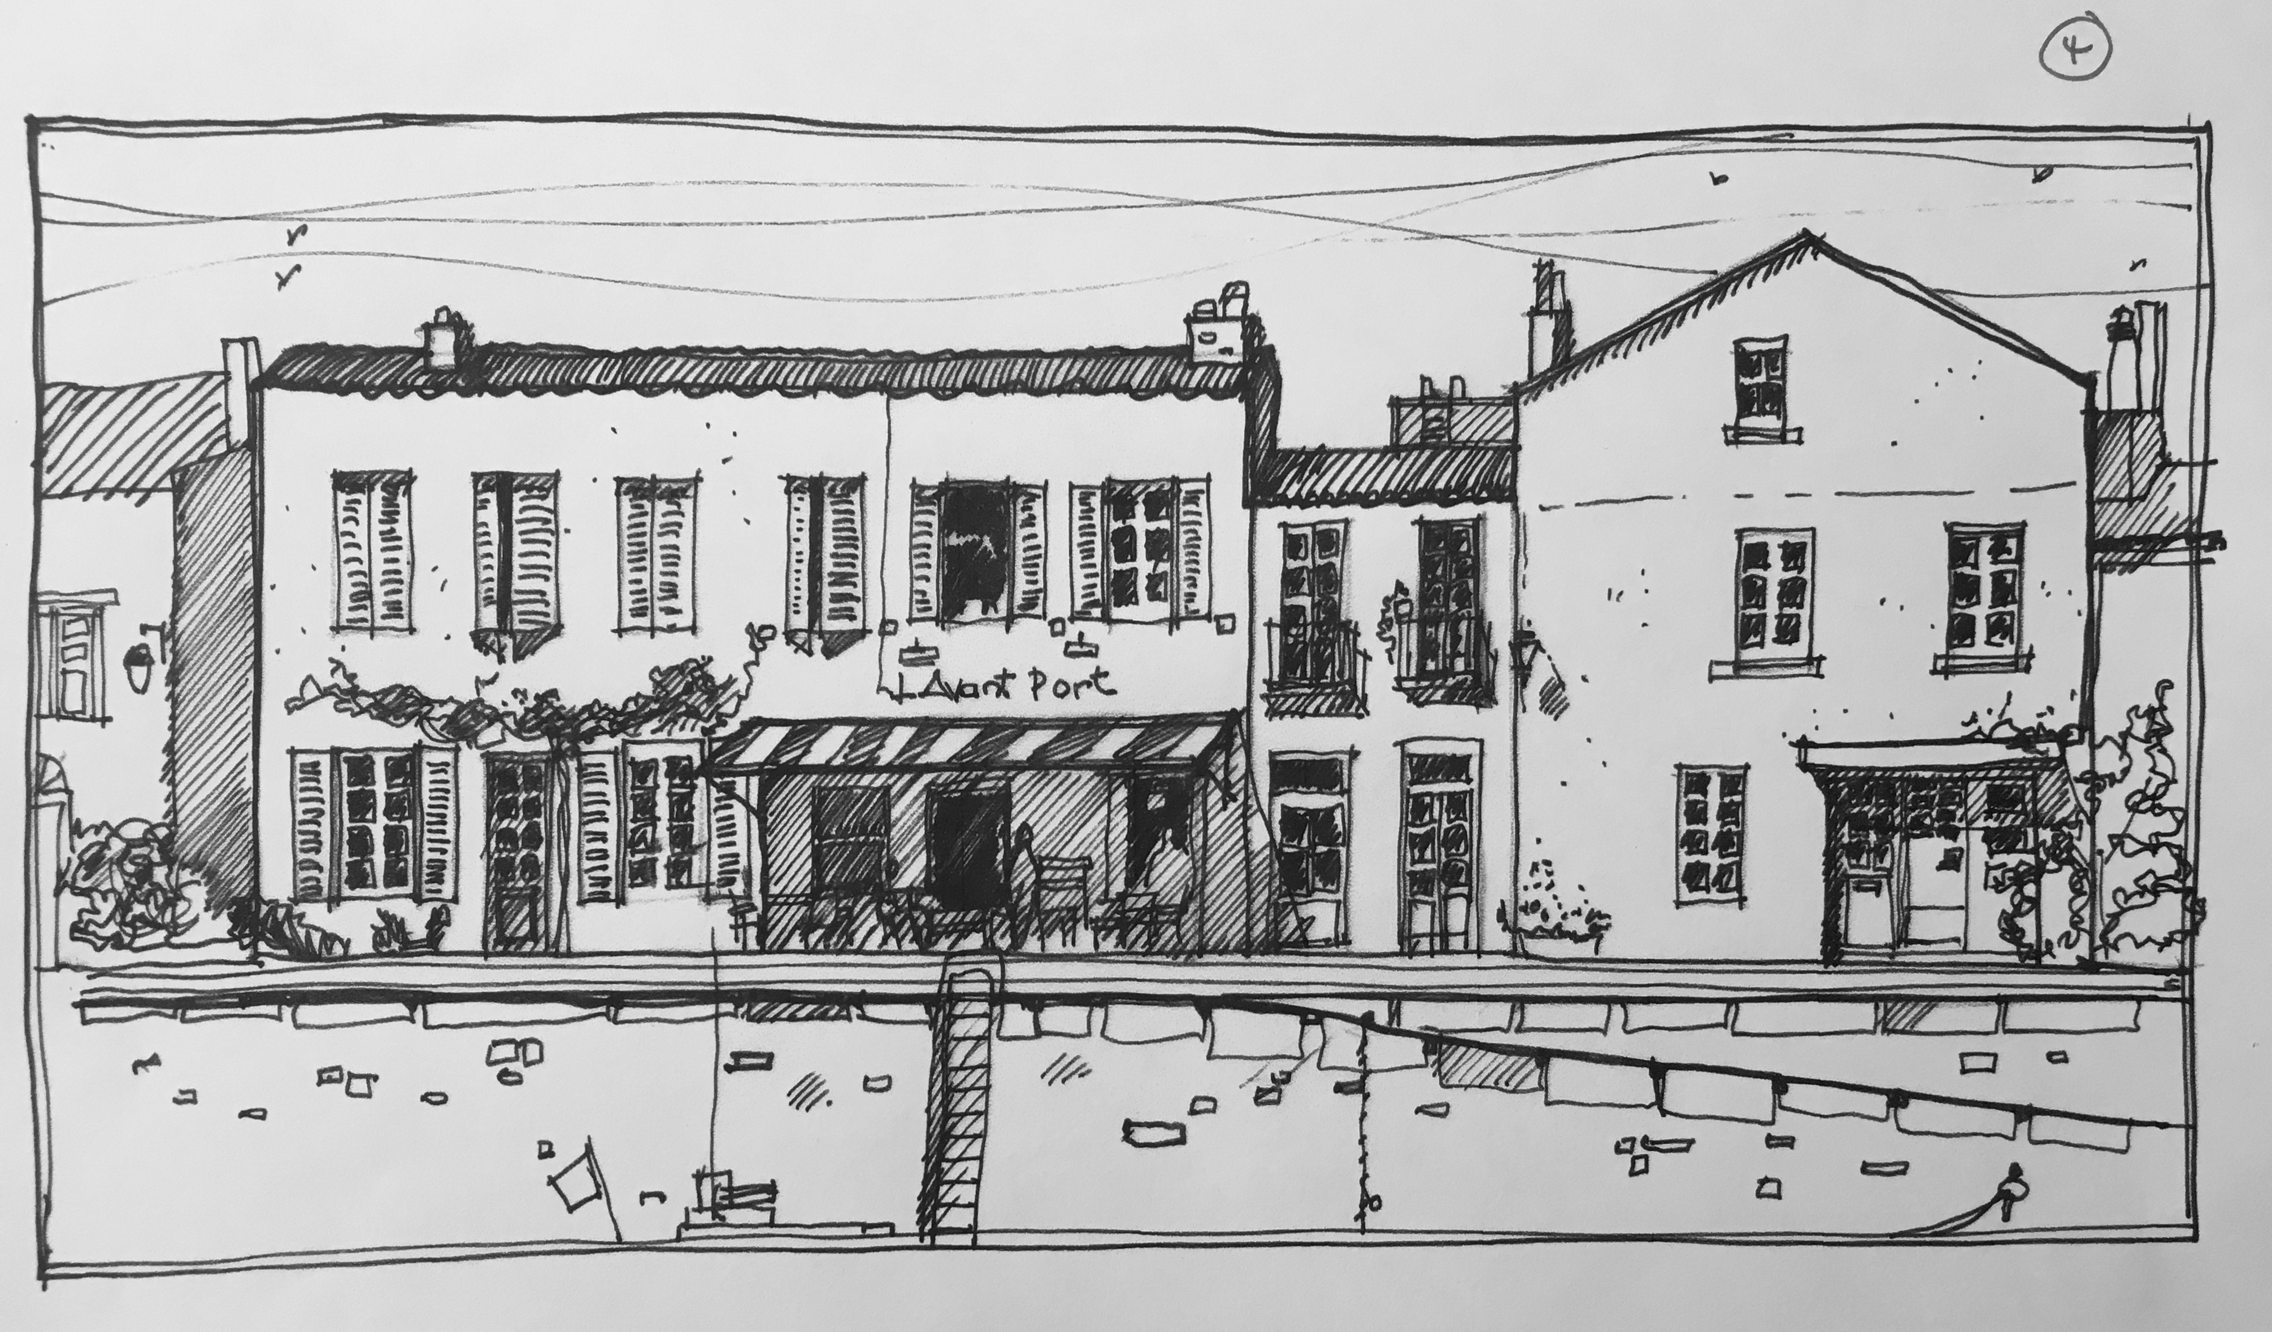
stop. Believe me there’s an art to doing this as well, knowing when a sketch is done, when it shouldn’t be tweaked any further, when the detail you need is there, and when the balance is right.
There’s a couple of final things to do..
Put a date on your drawing and note how long it took (that’s why I said note the time before you started)
Take some photographs of the scene. You may like to draw it again at home and your experiences on site along with the aide memoir of the photos will set you in good stead for approaching the view again.

Breathe, and move on to your next Urban Sketch…..

……Graham Thew September 2019

